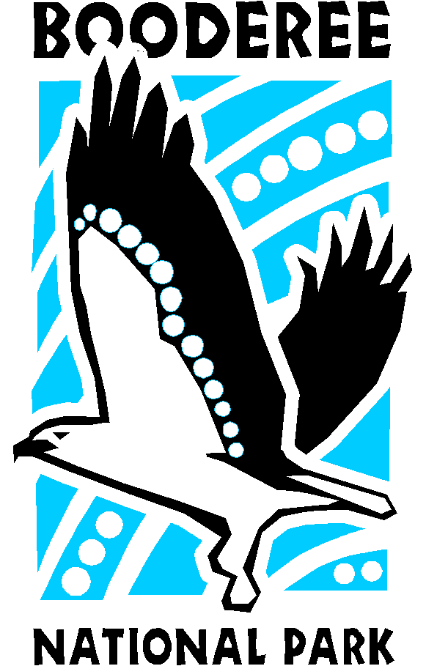
Booderee National Park

Guided Walks Group Booking Form

Organisers Details

Organisers Name:
Organisers Position:
Email Address:
Phone Number:

Organisation Details
Name of Organisation:
Address:
State: Postcode:
Type of Organisation: School University/TAFE Special Interest Group Other

School details (for schools to complete only)
Please tick:
Childcare Pre-school Primary Secondary TAFE University Other________
Year Level: ________________
Unit/Curriculum Links: ____________________

Participants Details
Total Number of Participants:
Number of Adults (please outline number of teachers): Number of children:
Do you have Aboriginal and Torres Strait Islander participants? *yes no
* If so, how many participants are Aboriginal and Torres Strait Islander? ____________
Does your group have any special requirements? *yes no
* Please describe _________________________________________________________________________
Activity Details

We currently provide one tour, the ‘Koori culture & bush tucker walk’ weekly on Tuesdays
Please select your preferred date and time slot for this walk. Please note, 30 people per group with a maximum of 60 people per timeslot. (E.g. two groups of 30 can be delivered in the same time slot)
Preferred Date of walk: Tuesday_________________ Alternate Date of walk: Tuesday __________________
10:00 am (max. 60 persons) 11:30 am (max. 60 persons)
1:00 pm (max. 60 persons) 3:00 pm (max. 60 persons)

Comments: _________________________________________________________________________

Submit this form to booderee.interps@environment.gov.au, and a confirmation with booking details will be sent in return
_________________________________________________________________________
Where Booderee National Park guided walks are unavailable you may wish to book Indigenous guided tours through Galamban Aboriginal Tours. See http://www.galamban.net for more information.

